Call for pricing The Turquoise Mermaid 972-841-3520 PO box 143 Mount Gilead Ohio 43338 [www.TheTurquoiseMermaid.com](http://www.TheTurquoiseMermaid.com)

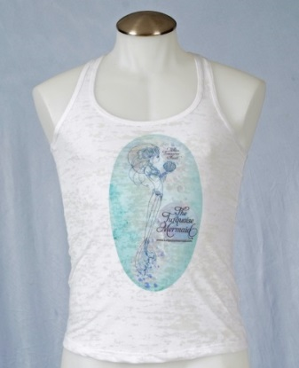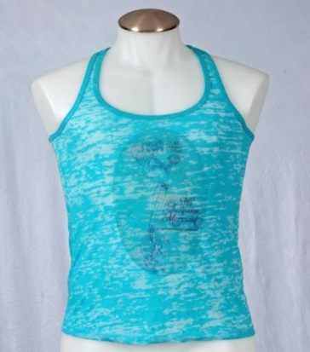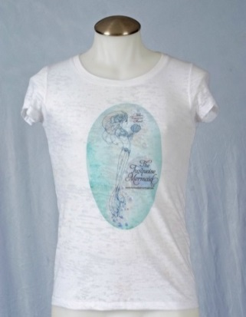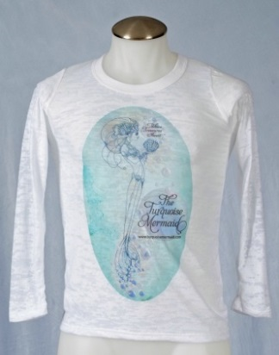

TTM W B/O Tank #26 TTM T B/O Tank w/logo #27 TTM W B/O TShirt #28 TTM W Long Sleeve B/O #25

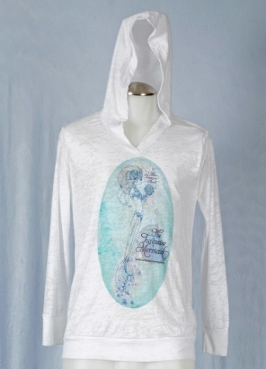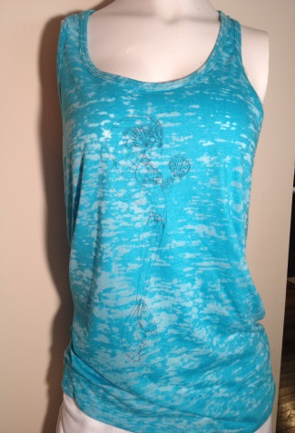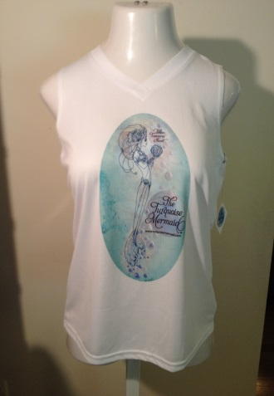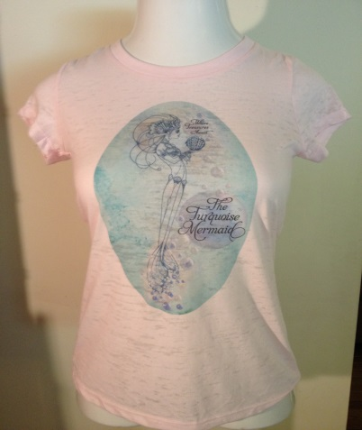

TTM W LS B/O Hoodie #29 TTM T Tank B/O line draw #32 TTM W Sport Sleeveless #30 TTM Pink B/O TShirt #31

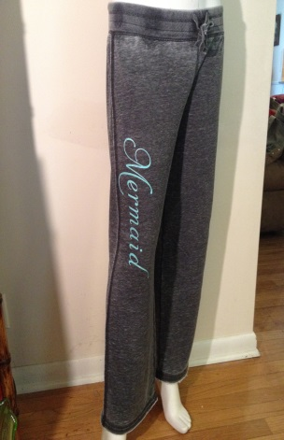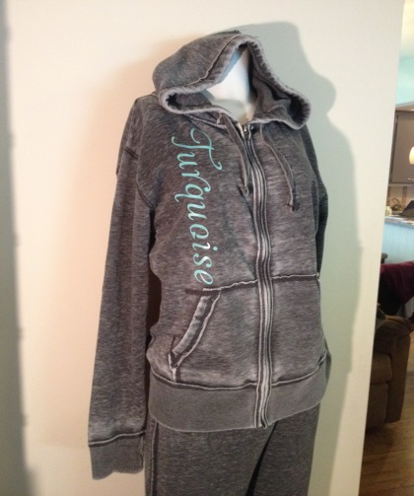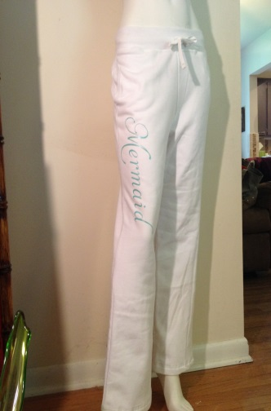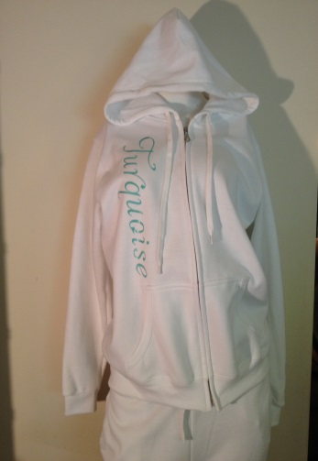 TTM B/O Char Pant #33 TTM B/O Char Hoodie #34 TTM W Plain Pant #35 TTM W Plain Hoodie #36

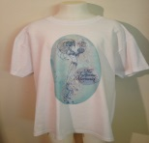 #37 TTM Childs TShirt